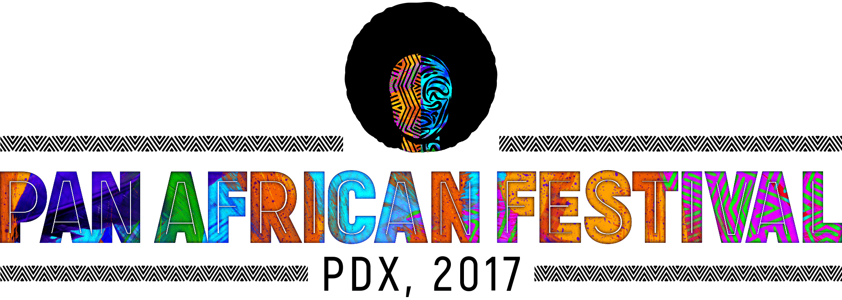

We are very excited to announce our vendors

Crafts & Merchandize
- Sistas LLC
- Multnomah County Library
- N'Kossi Boutique de l'Afrique
- Ethnic African Expressions
- Q & M Collective LLC,
- Sandals on my Feet
- Parker Simone Designs-
- Off the Hook D’signs
- Shalaunda Brown
- African Film Festival

Food Vendors
- Amalfi Restaurant
- Antilles Pearl Catering
- Black Star Grill
- Emame's Ethiopian Cuisine
- Ivory Coast
- Jamaican Cuisine
- Safari Restaurant

Partners
- Multnomah County Health Department
- Providence Health & Services
- Kaiser Permanente
- City of Portland

