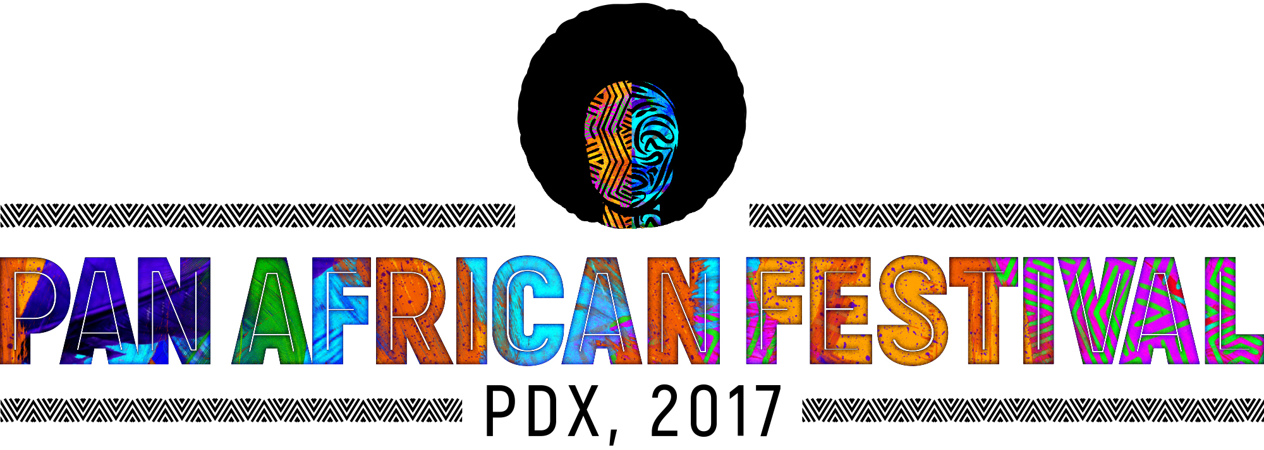
We are very excited to announce our speakers and entertainment line up!

Speakers
- Mayor Ted Wheeler
- Commissioner Loretta Smith
- Senator James Manning
- Rachael Banks
- Jimmy Dogo

Entertainment

DJ Solo

Fashion Shows: We got two awesome creative designers
- SISTAS LLC and SISTAS Dolled Up.
- N'Kossi Boutique de l'Afrique

Bands
- On Q
- The Roaring Lion
- Dialog
- Abundantly Blessed

Individual Performances
- Crystal Robinson
- Charles Robinson
- Mohamed Sheikh
- Blacque Butterfly
- Mic Crenshaw

Dance Groups
- Kokatonon
- African Youth Dance Group
Drumming
- Chatta Addy

